Study Guide for Final Exam

What is Strength?

Muscular strength: ______________________________________________________________

Muscular endurance: ____________________________________________________________

Elements of Muscular Fitness

- _________________: _____________________________________________________

Why is cardiovascular endurance the most important? ___________________________

- _________________: _____________________________________________________

- _________________: _____________________________________________________

What is Muscle?

- Muscle is made up of ____% water and ____% protein

3 Types of Muscle

- ________________ example: _____________________________________________

- ________________ example: _____________________________________________

- ________________ example: _____________________________________________

Roles Muscles Play

- _________________: prime mover, muscle primarily responsible to produce movement

- _________________: muscle in opposition to the agonist

- _________________: hold the joint steady while other muscles produce movement

- _________________: muscles that contract to prevent unwanted action

Types of Muscle Contractions

Isometric: _____________________________________________________________________

Example: _________________

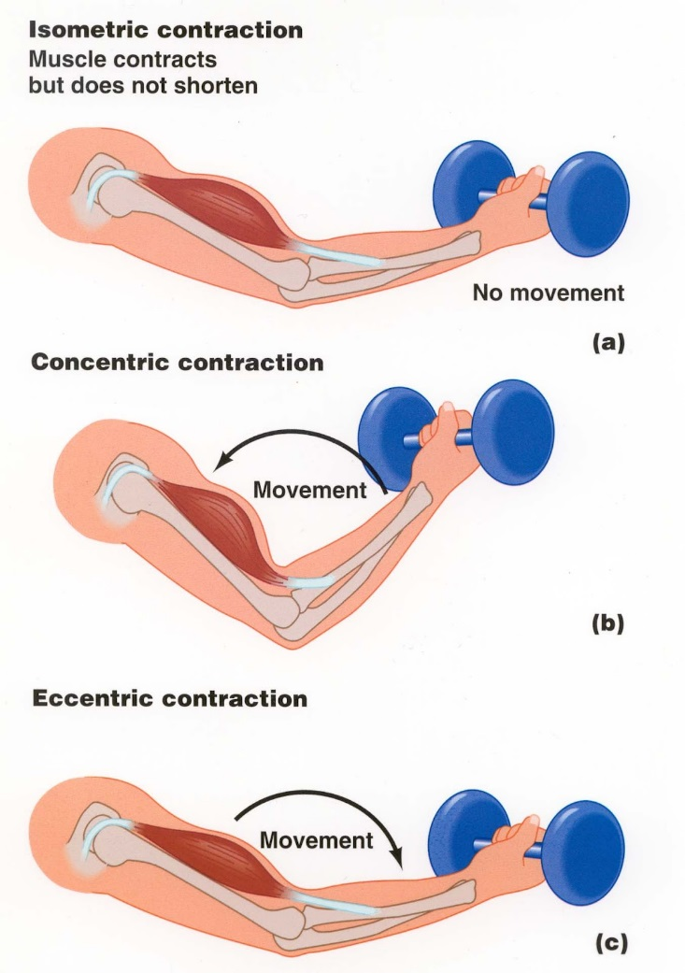
General Training Principles

- Principleof Overload: ______________________________________________________

F: _____________________

I: _____________________

T: ______________________

- Principle of Progression:
________________________________________________________________________

- Principle of Specificity: ________________________________________________________________________

General Training Terms

Reps: ____________________________________ Sets:____________________

________________________: increase in muscle size

________________________: decrease in muscle size

Resistance: ________________________________________________________________

1RM stands for: ____________________________________________________________

Plyometrics: _______________________________________________________________

10 Principles of Resistance Training

- ________________________; ___________________________________________

- ________________________; ___________________________________________

- ________________________; ___________________________________________

- ________________________; ___________________________________________

- ________________________; ___________________________________________

- ________________________; ___________________________________________

- ________________________; ___________________________________________

- ________________________; ___________________________________________

- ________________________; ___________________________________________

- ________________________; ___________________________________________

Nutrition/Supplements

- Body’s sources of energy

____________________ ____________________ ______________

- ___________________ repairs and builds muscle

- General Rule: ______ gram of protein per _____________ ______________

- _________________ __________________ increase testosterone.

Many ______________ _____________ are associated with anabolic steroids

- __________________= Most Important Nutrient

What is the best way to lose weight? _______________ & ____________________

Muscle Diagram
Anterior View
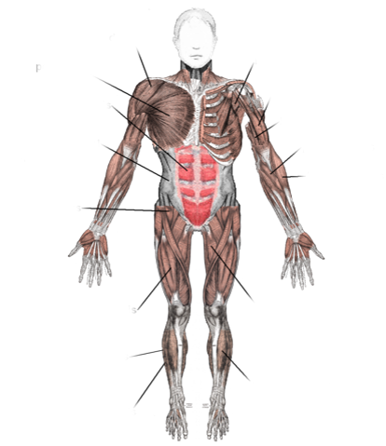

Posterior View

