Strength Training 1 Muscle Anatomy

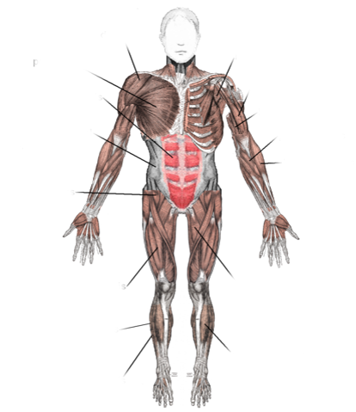

________________________ VIEW

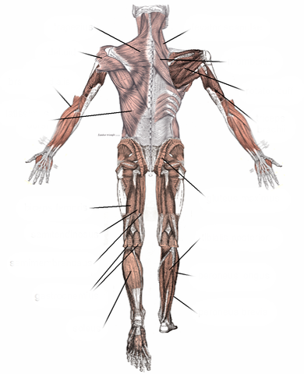

________________________ VIEW

